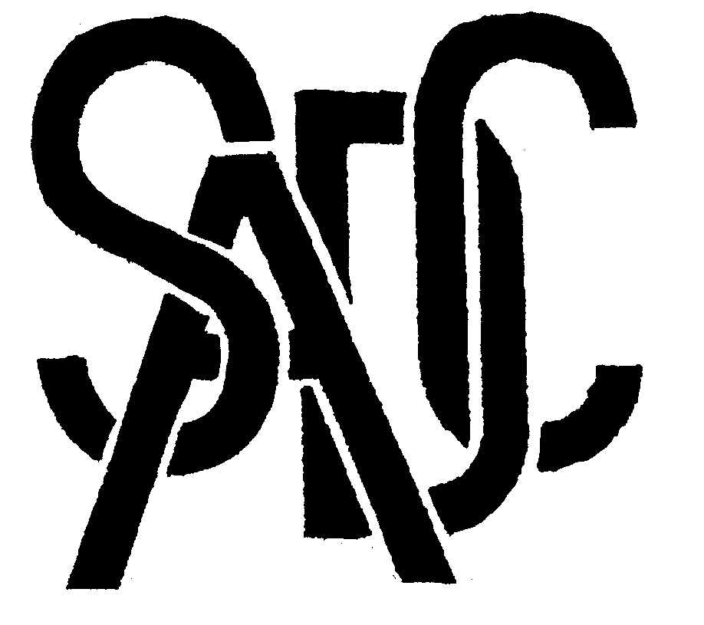

Southern African Development Community (SADC) Cooperation in Measurement Traceability
Angola, Botswana, Democratic Republic of Congo, Lesotho, Malawi, Mauritius, Mozambique, Namibia, Seychelles,
South Africa, Swaziland, Tanzania, Zambia, Zimbabwe

21 October 2005

Dear SADCMET Member

SADCMET Water PT Evaluation Workshop and Training Course on Measurement Uncertainty, 5-11 November, 2005 Dar es Salaam, Tanzania

Dear Sir/Madam

As part of our work programme for 2005/2006, SADCMET, with the support of PTB, is organising a second Water PT Evaluation Workshop as well as an extensive training course on Measurement Uncertainty, from 5-11 November 2005, in Dar es Salaam, Tanzania.

We would be most grateful if you could you please grant the requisite approvals for the representative from your Organisation who has participated in previous such Workshops to attend this one.

PTB will be meeting all related costs, including flight tickets, accommodation and daily allowances.

I have attached for your information a draft Workshop Programme.
Thank you for your usual cooperation.

Warm regards

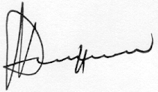
Dr M.T. Musarurwa
Regional Co-ordinator: SADCMET
CSIR-National Metrology Laboratory
Pretoria, South Africa
e-mail: mmusarurwa@csir.co.za
Tel. 27-12 841 3898
Fax 27-12 841 2131

